**Experiment-1:**

**Q1. Given an integer *n* perform the following conditional actions:**

* **If  *n* is odd, print Weird**
* **If *n* is even and in the inclusive range of 2  to 5 , print Not Weird**
* **If  *n* is even and in the inclusive range of  6 to 20, print Weird**
* **If *n* is even and greater than 20, print Not Weird**

**Q2. WAP to read an integer ‘n’ from STDIN. For all non-negative integers i<n, print i2 on a separate line.**

**Sample input**

**3**

**Sample Output**

**1**

**2**

**4**

**Example**

**The list of non-negative integers that are less than 3 is [0, 1, 2]. The square of each number is given below:**

**0**

**1**

**4**

**Q3. WAP to read an integer from STDIN. Without using any string methods, print the following on a single line:**

**123…n**

**Note that … represents the consecutive values in between.**

**Example**

**n=5**

**Output- 12345**

**Experiment-2:**

**Q1. WAP to read the record of n students in a dictionary containing key/value pairs of name: [marks]. Print the average of the marks obtained by the particular student correct to 2 decimal places.**

**Input Format**

**The first line contains the integer n, the number of student’s records. The next n lines contain the names and marks obtained by a student, each value separated by a space.**

Sample Input

**3**

**Krishna 67 68 69**

**Arjun 70 98 63**

**Malika 52 56 60**

Sample Output

56.00

**Q2. WAP to input a list of scores for N students in a list data type. Find the score of the runner-up and print the output.**

**Sample Input**

**N = 5**

**Scores= 2 3 6 6 5**

**Sample output**

**5**

**Note:**

**Given list is [2, 3, 6, 6, 5]. The maximum score is 6, second maximum is 5. Hence, we print 5 as the runner-up score.**

**Q3. Rupal has a huge collection of country stamps. She decided to count the total number of distinct country stamps in her collection. She asked for your help. You pick the stamps one by one from a stack of country stamps.Find the total number of distinct country stamps using a suitable data type.**

**Note: Apply your knowledge of the***.add()***operation from set to help your friend Rupal.**

**Experiment-3:**

**Q1. Write a program to enter a string and a substring. You have to print the number of times that the substring occurs in the given string. String traversal will take place from left to right, not from right to left.**

Sample Input

ABCDCDC

CDC

Sample Output

2

**Q2. WAP to input the first name, middle and last name of a person. Your task is to print the initials of the first and middle name separated by a dot (.)**

**The last name should be followed by a dot and a space where the first letter is capital.**

Sample Input

Mohandas KaramChand Gandhi

Sample Output

M.K. Gandhi

**Q3. Given a string containing both upper and lower case alphabets. Write a Python program to count the number of occurrences of each alphabet (case insensitive) and display the same.**

Sample Input

ABaBCbGc

Sample Output

2A

3B

2C

1G

**Experiment-4:**

**Q1. Using functions, re-write and execute Python program to:**

**1. Add natural numbers upto n where n is taken as an input from user.**

**2. Print Fibonacci series till nth term (Take input from user).**

**Q2. At an airport, a traveler is allowed entry into the ﬂight only if he clears the following checks:**

**1. Baggage Check**

**2. Immigration Check**

**3. Security Check**

**The logic for the check methods are given below:**

**check_baggage (baggage_weight)**

**returns True if baggage_weight is greater than or equal to 0 and less than or equal to 40. Otherwise returns False.**

**check_immigration (expiry_year)**

**returns True if expiry_year is greater than or equal to 2030 and less than or equal to 2050. Otherwise returns False.**

**check_security(noc_status)**

**returns True if noc_status is 'valid' or 'VALID', for all other values return False.**

**traveler()**

**Initialize the traveler Id and traveler name and invoke the functions check_baggage(), check_immigration() and check_security() by passing required arguments.**

**Refer the table below for values of arguments.**

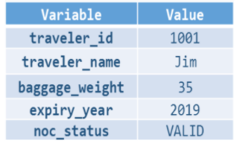

**If all values of check_baggage(), check_immigration() and check_security() are true,**

**display traveler_id and traveler_name**

**display "Allow Traveler to ﬂy!"**

**Otherwise,**

**display traveler_id and traveler_name**

**display "Detain Traveler for Re-checking!**

**Invoke the traveler() function. Modify the values of diﬀerent variables in traveler() function and observe the output.**

**Q3. Write a Python program to find the maximum and minimum values in a given list of tuples using lambda function.**

**Original list with tuples:  
[('V', 62), ('VI', 68), ('VII', 72), ('VIII', 70), ('IX', 74), ('X', 65)]  
Output-**

**Maximum and minimum values of the said list of tuples:  
(74, 62)**

**Experiment-5:**

**Q1. Write a Python program to:**

**1. read a ﬁle.**

**2. add backslash (\) before every double quote in the ﬁle contents.**

**3. write it to another ﬁle in the same folder.**

**4. print the contents of both the ﬁles.**

**For example:**

If the ﬁrst ﬁle is 'TestFile1.txt' with text as:

Jack said, "Hello Pune".

The output of the ﬁle 'TestFile2.txt' should be:

Jack said,\"Hello Pune\".

**Q2. Consider a ﬁle 'rhyme.txt' in D Drive with following text:**

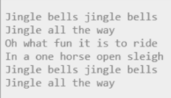

**Write a Python program to count the words in the ﬁle using a dictionary (use space as a delimiter). Find unique words and the count of their occurrences (ignoring case). Write the output in another ﬁle "words.txt" at the same location.**

**Q3. Assume a file city.txt with details of 5 cities in given format (cityname  population(in lakhs) area(in sq KM) ):**

**Example:**

**Dehradun 5.78 308.20**

**Delhi 190 1484**

**……………**

**Open file city.txt and read to:**

**Display details of all cities**

**Display city names with population more than 10Lakhs**

**Display sum of areas of all cities**

**Experiment-6:**

**Q1. Input two values from user where the first line contains N, the number of test cases.  
The next N lines contain the space separated values of a and b. Perform integer division and print a/b. Print the error code in the case of *ZeroDivisionError* or *ValueError*.**

Sample input

1 0

2 $

3 1

Sample Output

Error Code: integer division or modulo by zero

Error Code: invalid literal for int() with base 10: '$'

3

**Q2. Assume the following Python code-**

**Rewrite the code to handle the exceptions raised. Print appropriate error messages wherever applicable.**

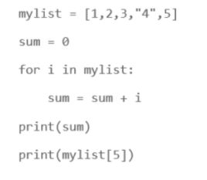

**Q3. You have already created a Python program to implement the following in ﬁle handling section:**

**1. read a ﬁle.**

**2. add backslash (\) before every double quote in the ﬁle contents.**

**3. write it to another ﬁle in the same folder.**

**4. print the contents of both the ﬁles.**

**For example:**

**If the ﬁrst ﬁle is 'TestFile1.txt' with text as:**

**Jack said, "Hello Pune".**

**The output of the ﬁle 'TestFile2.txt' should be:**

**Jack said,\"Hello Pune\".**

**Modify your code to implement Exception handling. Print appropriate error messages wherever applicable.**

**Experiment-7:**

**Q1.**

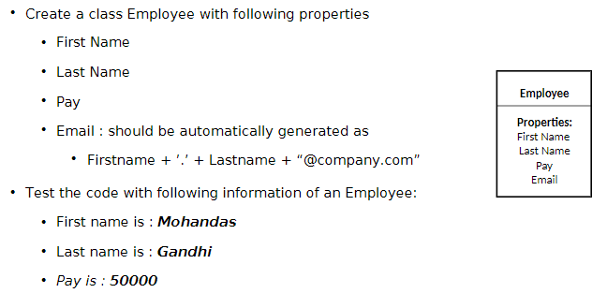

**Q2. Perform the following instructions:**

1. **Create a Vehicle class with max_speed and mileage as instance attributes. Additionally, create a method named seating_capacity() using the below syntax:**

**defseating_capacity(self, capacity):**

**returnf"The seating capacity of a {self.name} is {capacity} passengers"**

1. **Create child class ‘Bus’ that will inherit all of the variables and methods of the Vehicle class. Set the seating capacity of the bus to 50 using super().**
2. **Create a Bus object that will inherit all of the variables and methods of the Vehicle class and display it.**
3. **Define a class attribute “color” with a default value white. I.e., Every Vehicle should be white.**

**Q3. List the risk associated with the implementation of Account class. Suggest a solution.**

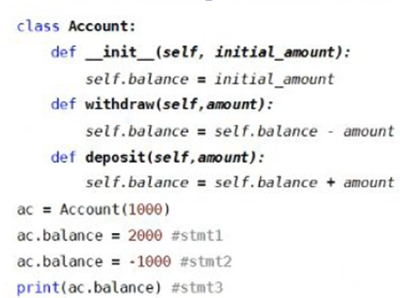

**Experiment-8:**

**Q1.**

1. import Tkinter package and create a window and set its title
2. set the default window size using geometry function
3. Create a label with “Hello” text in it and set its position on the form.
4. Add a button to the window with “CLICK ME” written on it.
5. change the foreground and background color for the button created above
6. Create a function that will be executed when the button is clicked and print “Button was clicked” on clicking the button

**Q2. This is the continuation of Question1, add the given below features in the above program:**

1. Take user name as input using the Tkinter Entry class
2. Print the entered text (username) on clicking the button.
3. Create three Radio Buttons as displayed below:



1. Print the currently selected radio button or the radio button value.

**Q3. Write a program to accept following details from a student using GUI**

1. Name of the student (using Textbox)

2. Gender (Using radio button)

3. Qualification (Using List)

4. Marks of three subjects (using Textbox)

**Compute the percentage of the student and display it in a textbox.**

**Experiment-9:**

**Q1.**

1. Convert numbers =[1, 2.0, 3] to numpy array and convert all elements to string type.
2. Create a 2 D array through list and set dtype as int32
3. Find the rows and columns of the 2d array created in part b
4. Print 10 random numbers between 1 and 100.

**Q2.**

1. Write a NumPy program to get help on the add function
2. Write a NumPy program to test whether none of the elements of a given array is zero
3. Write a NumPy program to test whether any of the elements of a given array is non-zero
4. Write a NumPy program to generate an array of 15 random numbers from a standard normal distribution

**Experiment-10:**

**Q1. Refer the given excel file and perform various operations using pandas library:**

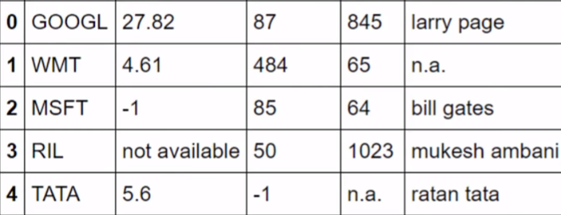

1. Read the above excel file in python.
2. How do I write this file to a new file “new.csv”?
3. Include column names in this file. Use ‘ticker’, ‘eps’, ‘revenue’, ‘price’, ‘people’ as column names.
4. Convert all not available or n.a. values to NAN and also convert negative revenues to NAN because revenues can never be negative.
5. Fill NAN values using a suitable approach.
6. Write a function to change n.a value appearing in WMT to Sam Walton